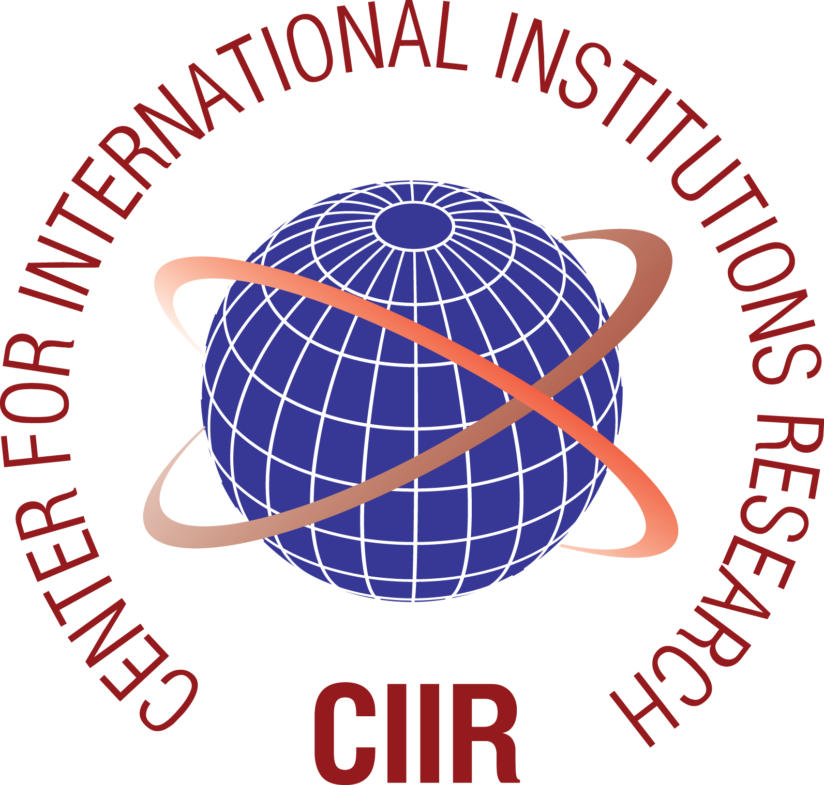 | 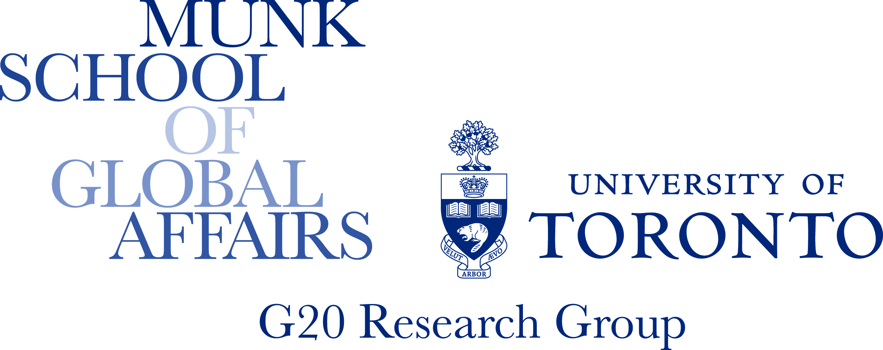
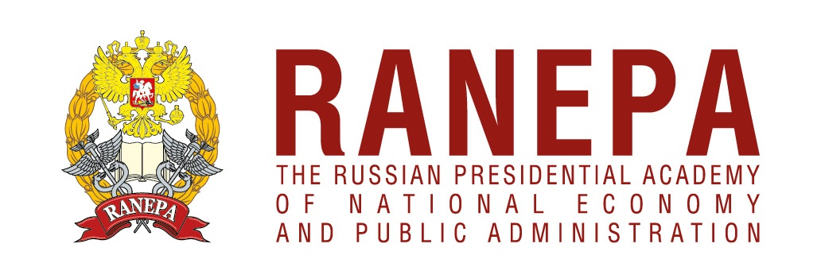 | 
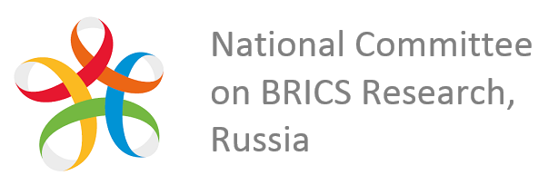 | 

International conference

“G20 and BRICS – new global governance institutions”

Draft programme (as of July 6, 2016)

October 25, 2016

Venue: Russian Presidential Academy of National Economy and Public Administration (RANEPA) (Room 523, Building 5, 82/5, Prospect Vernadskogo, Moscow, Russian Federation)

Working languages: Russian and English

10:00-10:30 | Keynote statements  The introductory session opens up with a welcome statement from the Rector of RANEPA Vladimir Mau and keynote statements from Russian G20 Sherpa Svetlana Lukash and BRICS Sherpa Sergei Ryabkov  Moderator: Pavel Kadochnikov, Vice-Rector for Research, Russian Foreign Trade Academy  Welcome statement  Vladimir Mau, Rector, Russian Presidential Academy of National Economy and Public Administration (RANEPA)  G20: Achievements and Priorities  Svetlana Lukash, Russian G20 Sherpa, Deputy Head of the Presidential Experts’ Directorate  BRICS: Together for Growth and Development  Sergei Ryabkov, Russia's BRICS Sherpa, Deputy Foreign Minister of the Russian Federation
10:30 – 12:00 | Session 1. From Overcoming Economic Crisis to Boosting Growth  In Session 1, participants are invited to review the G20 and BRICS contribution to overcoming economic crisis, provide insights on the G20’s influence on its national regulation and business climate and explore how/if the G20 and BRICS can unlock the growth and productivity potential of innovation. Given the transition from the 2016 Chinese G20 Presidency to the 2017 Chinese BRICS Presidency, this discussion will also explore opportunities for continuity between the two groupings’ agendas.  Moderator: Sergey Drobyshevsky, Scientific Director, Ye.T. Gaidar Institute for Economic Policy  G20 and BRICS: Cooperation for Growth  Alexey Likhachev, First Deputy Minister of Economic Development of the Russian Federation  G20 Contribution to Overcoming Economic Crisis  John Kirton, Co-director, BRICS Research Group, Co-director, G20 Research Group, Director, G8 Research Group, Munk School of Global Affairs, University of Toronto  BRICS: Cooperation for Economic Growth and Development  Georgy Toloraya, Chair of the Regional Programs Department, “Russkiy Mir” Foundation, Executive Director of the National Committee on BRICS Research (Russia)  G20 Decisions Influence on National Regulations and Business Climate in the Member Countries  Mike Callagan, Nonresident Fellow, Lowy Institute for International Policy  Unlocking New Growth Drivers: Innovation, New Industrial Revolution and Digital Economy in G20 and BRICS Agendas  Guo Shuyong, Dean of the School of International Relations and Public Affairs (SIRPA), Shanghai International Studies University (SISU)  G20 and the Functioning of International Monetary System  Paola Subacchi, Research Director, International Economics, Chatham House  Interventions:  Evsey Gurvich, Head, Economic Expert Group (EEG)  Güven Sak, Managing Director, TEPAV
12:00-12:30 | Coffee break
12:30-14:00 | Session 2. Persisting Challenges: What G20 and BRICs Actions are needed?  Session 2 explores multiple persisting challenges which G20 and BRICS face: the gap in infrastructure investment, trade and investment systems fragmentation and protectionism, reform of the international monetary system (IMS) and tax governance. Participants will discuss what actions in these policy areas are needed to generate strong, sustainable, balanced and inclusive growth.  Moderator: Paola Subacchi, Research Director, International Economics, Chatham House  Global Infrastructure Challenge and Role of G20/BRICS  Zia Qureshi, Nonresident Senior Fellow, Global Economy and Development, Brookings Institution  Can the new Banks help bridge the gap in infrastructure investment?  Hannah Wurf, Research Associate, G20 Studies Centre, Lowy Institute for International Policy  Next Steps towards the IMS Reform  Gabriel Di Bella, Resident Representative of the IMF in Moscow  What Trade and Investment Regimes Should G20 and BRICS Support?  Jan Wouters, Full Professor of International Law and International Organizations, Director, Leuven Centre for Global Governance Studies - Institute for International Law, KU Leuven  Trade: Can it Help Overcome Economic Crisis?  Sang-Chul Park, Professor at Graduate School of Knowledge Based Technology and Energy, Korea Polytechnic University  Global Tax Governance  Zhu Jiejin, Associate Professor, Center for BRICS Studies, School of International Relations and Public Affairs, Fudan University  Interventions:  Natalia Khmelevskaya, Associate Professor of the Department of Foreign Economic Ties and International Economic Relations, Moscow State Institute of International Relations of Ministry of Foreign Affairs of Russia  Maxim Bratersky, Leading Research Fellow, Centre for Comprehensive European and International Studies (CCEIS), Professor, Faculty of World Economy and International Affairs / School of International Affairs, National Research University Higher School of Economics
14:00-15:00 | Lunch
15:00- 16:30 | Session 3. Agenda for Future Presidencies  In Session 3, participants are invited to reflect on priorities for the 2017 German G20 and the 2017 Chinese BRICS Presidencies. The G20 and BRICS as drivers of the global development agenda will be the key focus of this debate. Given that the order of future rotating chairmanships in both institutions has been established, speakers will look into the future to consider possible agenda priorities for both the 2018 Argentinian G20 and 2019 India G20 Presidencies. Moderator: Dries Lesage, Professor, Department of Political Science, Ghent Institute for International Studies, Ghent University  India’s Vision of BRICS Future Priorities and Perspectives for India G20 2019 Presidency  H.E. Pankaj Saran, Ambassador of India to the Russian Federation  Priorities of the China BRICS 2017 Presidency  Huang Wei, Senior Research Fellow, Supervisor of Postgraduate, Director of Research Department of Global Governance, Executive Director of Centre for International Economic and Strategic Studies, Institute of World Economics and Politics, Chinese Academy of Social Science  G20 and BRICS as Drivers of Development Agenda  Andras Horvai, Country Director and Resident Representative for the Russian Federation, Europe and Central Asia, World Bank  Priorities of the German G20 Presidency  Thomas Fues, Head of Department, German Development Institute (DIE)  Looking Ahead into the G20’s Future Agenda  Maria Monica Wihardja, Lecturer, University of Indonesia  Interventions (Looking Ahead into the BRICS Future Agenda):  Victoria Panova, Director, Institute of Oriental Studies, School of Regional and International Affairs, Professor, IR Department, Far Eastern Federal University, Strategy Planning Advisor, National Committee on BRICS Research  Natalia Volchkova, Assistant Professor, New Economic School
16:30-17:00 | Coffee break
17:00-18:30 | Session 4. G20 and BRICS: Evolving Institutional Identity  Session 4 will focus on the G20 and BRICS institutional development, their evolving identity, as well as modes and perspectives of engagement with other international organizations.  Moderator: Ella Kokotsis, Director of Accountability, G8 and G20 Research Groups, Munk School of Global Affairs, University of Toronto  Business Perspective for the G20/BRICS Future Priorities  Jean-Guy Carrier, Former Secretary General, International Chamber of Commerce (ICC)  Between Hub Status and Parallelism  Andrew F. Cooper, Professor, Department of Political Science and Balsillie School of International Affairs at the University of Waterloo, Director, Centre for the Study on Rapid Global Change at the University of Waterloo  G20 and BRICS: Engaging with International Organizations to Generate Growth  Marina Larionova, Head of the Center for International Institutions Research (CIIR), Russian Presidential Academy of National Economy and Public Administration (RANEPA)  Vision for the G20 Reform as a New Global Governance Mechanism  Marek Rewizorski, Associate Professor at the Institute of Political Science, Faculty of Social Science, University of Gdańsk  Mexico and its MIKTA Response to BRICS  Stephan Sberro, Professor at Department of International Studies, Mexico Autonomous Institute of Technology, Co-director of the Institute of European Integration Studies, National Researcher of CONACYT  Interventions:  Michele Carducci, Full Professor of Comparative Law, European-American Constitutional Policy Research Centre, University of Salento
18:30-19:30 | Session 5. BRICS and G20 in the System of Global Governance  Session 5 will wrap up on the day’s discussions. Participants will reflect on why and how the BRICS and G20 can provide better global governance and whether they should act in cooperation or competition with other global plurilateral summit institutions (PSIs). This session will summarize the main conclusions from the day’s conference proceedings.  Moderator: Marek Rewizorski, Associate Professor at the Institute of Political Science, Faculty of Social Science, University of Gdańsk  BRICS in the System of Multilayered Governance  Maria Raquel Freire, Director of PhD Programme in International Politics and Conflict Resolution, University of Coimbra  G20 and BRICS: Enhancing Delivery Legitimacy  Ella Kokotsis, Director of Accountability, G8 and G20 Research Groups, Munk School of Global Affairs, University of Toronto  G20 and BRICS – New Global Governance Institutions  Vladimir Zuev, Professor, Institute of Trade Policy, Department of Trade Policy, National Research University Higher School of Economics

